**Creating a bar graph in tableau**

You can use Tableau to reproduce the figures in the [Statistics Canada table](https://www150.statcan.gc.ca/t1/tbl1/en/tv.action?pid=1410001702) and present them visually. The data in the sample dataset is the same used to produce the Statistics Canada table.

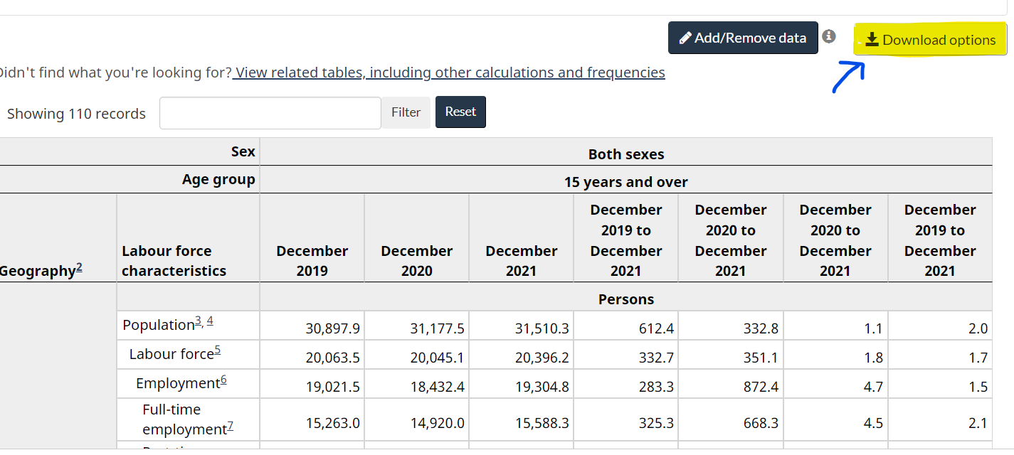

Source: Statistics table (GitHub 2020)

**Step 1: Adding dimensions and measures**

1. Go to Worksheet -> New Worksheet
2. Right-click the new worksheet tab (bottom of the screen) and rename the sheet to ‘Unemployment rate’

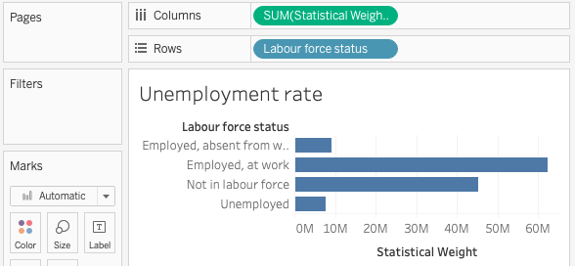

1. Drag Labour Force Status to Rows
2. Drag Statistical weight to Columns

**Step 2: Adding labels**

1. There are at least two ways to add labels showing the sum of Statistical Weight for each Labour force status:
2. Open the Analysis menu and select Show Mark Labels, OR  
   In the Marks card, click Label then put a check next to Show mark labels

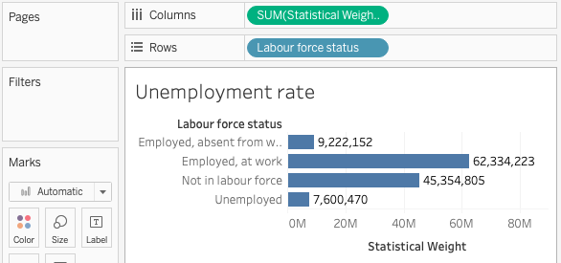

**Step 3: Add a filter**

1. We now have a bar graph showing an estimate of the population in each Labour Force Status category. But this number is four times too high because we have four months of data. To see the number of unemployed people in a single month, limit to January survey responses in one of two ways:
2. Right-click Survey month and select Show Filter, OR
3. Drag Survey month onto the Filters card.

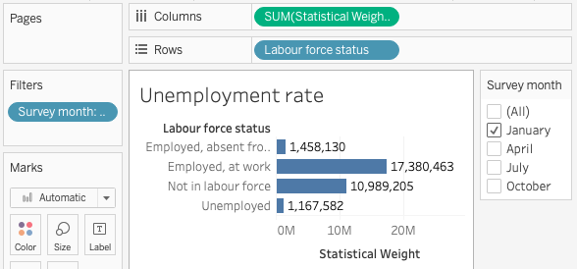

**Step 4: Show as percentage of total**

1. We are interested in the unemployment rate which is represented as a percentage of the population, but our labels show the actual population. To show percentages instead of sums:
2. Right-click the green Statistical Weight pill in the Columns shelf and select Quick Table Calculation -> Percent of Total

